

VA Financial Services Center
Centralized Construction Payments
User’s Guide

Overview

The Centralized Construction Payment process works in cooperation with the Online Certification System (OLCS). The Financial Services Center (FSC) developed the OLCS based on input and suggestions from you, our customers. This system is designed to be a simple and effective means for Certifying Officials, Project Managers, Project Engineers, and others to view and certify invoices without the manual burden of routing paper invoices throughout multiple locations.

This Centralized Construction Payments User Guide was developed to assist the Contract Officer and Project Engineer / Project Manager with Construction specific procedures. If you are not familiar with the OLCS process, you may access the OLCS Online Help guide located on the VAFSC Online Certification logon page.
Construction Invoices: The FSC Construction Payment Processing Section processes Major/Minor Construction and Non-Recurring Maintenance Construction invoices only. The setup of the Purchase Order (PO) determines if an invoice is a Construction Invoice. One or both of these criteria are used to determine if it is a construction invoice:
- Cost Center 8542 (Non-Recurring Maintenance)
- Major/Minor Construction Fund Codes
  - 0110 (Major Construction)
  - 0111 (Minor Construction)
  - 4538 (Parking Structures)
If the PO associated does not meet one or both of these criteria, it is NOT considered a construction invoice and should instead be faxed to the Commercial Payment Section at (512) 460-5540.
Vendors can fax Construction invoices directly to the FSC (512-460-5545) which automatically scans them into Document Management System (DMS), and assigns a unique document locator number (DLN). In addition to a unique identifier, the DLN describes when and where the document entered the system. Vendors may choose to mail invoices directly to the FSC using the address below. Usually within 48 hours these documents will be scanned into DMS and assigned a DLN.

Department of Veteran’s Affairs
Financial Services Center
P.O. Box 149975
Austin, TX 78714-8975
Attn: CAT (0474)
If you experience trouble with any of the following areas, please refer to the OLCS Online help located on the OLCS main logon page.
- System and Browser Specifications
- General Desktop Settings
- Internet Explorer Settings
- Remote Access
- Logging onto and out of the Online Invoice Certification System
- Passwords
- Image Viewer Browser Plug-in
- General OLCS How To
Construction Invoice Processing
The DMS is the FSC's optical imaging system used to route and process all documents in a paperless form. Once scanned into the DMS, the invoice becomes an electronic image where it can be stored in its electronic form for the remainder of its useful life.
Indexing: Once the invoices are received in the system, they are indexed with the information required to process the invoices including:
- Project Number
- Project Name
- Invoice Number
- Purchase Order Number (also known as Doc Number)
- Contract Number
- Fund Control Point/Accounting Classification Code Number (also known as FCPACC)
- Invoice Number or Progress Payment Number
- Invoice Amount
- Vendor ID
Purchase Orders: The correct purchase order is crucial to processing invoices using the system. Once the invoice has been indexed, it is sent to OLCS for station approval and certification. The OLCS system will identify the FCP associated with the purchase order. Using the FCPACC the system will route the invoice to the appropriate station personnel. If there is no PO in FMS or if there is no FCPACC associated in OLCS with that PO, the station’s site administrator is responsible for correcting the PO. If the vendor does not provide a PO, a dummy PO is entered by the FSC Construction Payment Processing Section in the format; station number followed by six zero’s (104000000). Invoices with a dummy PO, or an Invalid POs, or No FCPACC appear on the station site administrator’s report. The site administrator must login, blank out the Fund Control Point (FCPACC) and enter the correct PO#. Failure to blank out the FCPACC will result in an “Invalid FCPACC” error. Only the site administrator can apply the proper PO#.
Approving and Rejecting Invoices: With a proper PO and FCP entered in the system, the invoice will route to the appropriate station personnel as established by the station’s site administrator. Changes, additions, and deletions to the assignments should be routed to your site administrator for processing. There are two levels of certification possible in the OCLS system, ‘clerk’ and ‘user.’ Major/Minor construction requires two-level certification but NRM only requires one. A station, at its discretion, can assign two level of certification to NRM projects if desired. Specifics on the roles and processing are discussed in detail later in this guide.
The station personnel assigned can either approve the invoice for payment or reject the invoice. Rejected invoices are routed back to the FSC Construction Payment Processing Section who will return the invoice to the vendor with an explanation as provided by the station. Approved invoices are routed to the FSC Construction Payment Processing Section where the payment is processed in FMS.
Archived Invoices: Once the invoice is processed (payment or return), it is archived for future reference. The archive maintains all annotations added to the document, the electronic certification stamps or reject letters, and any attachments. These records and retained in the archive for the period of time specified by the documents retention policy.

SQL Launcher Queue Names: SQL Launcher can be used to track the location of invoices. Listed below are the queue names included with their descriptions:

QUEUE NAME DESCRIPTIONS
SPLITDEL Contains all of the fax pages that were faxed before
invoices were split

ARCHCAT An invoice in the process of being archived in the system

CAT An invoice has been processed and archived in the system

FAXHOLD The invoice is awaiting certification in OLCS by clerk/user

CAT_INDEX The invoice is awaiting process by Austin, either for
payment or to be sent back to vendor if invoice is rejected.

CAT_HOLD The invoice is on hold pending additional information
before payment processing (i.e.: additional funds to be
added or vendor information updated)

Using OLCS for Construction Payments: The following section gives specific instructions based on the role in OCLS. Typical roles are CLERK, USER, and SITE ADMIN. The SITE ADMIN manages and assigns the other users in the system for that station. They also manage the FCPACC/PO assignments. They are the one responsible for setting up FCPACC for single or dual certification.
The CLERK role in the construction process is usually setup as the Project Manager or Project Engineer. The actual person assigned is left to station discretion. The CLERK always approves the document FIRST in the system if dual certification is setup.
The USER role in the construction process is setup for the Certifying Official. This role certifies the documents as being proper for payment. The USER always approves SECOND if dual certification is required otherwise they are the only approver.
NOTE: MAJOR/MINOR construction projects using FUNDS/Appropriations 0110, 0111, and 4538 MUST have two levels of certification. Invoices with only one certification will be returned to the station for correction.
Main Menu
Once you have successfully logged into the OLCS, you will see the main menu page, as shown below. There are 3 levels of access to the system, Administrator, Project Engineer or Project Manager, and Contract Officer. Usually there are one or more administrators for each facility. Depending on your access level, you will see different options on the main menu.
Site Administrator
The options seen below are available when the Site Administrator logs on.
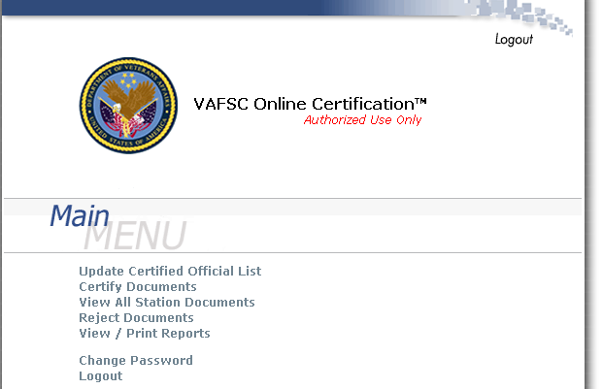
- Update Certified Official List - Use this option to add, modify, or delete Contract Officers and Project Engineers / Project Managers
- Certify Documents - Use this option to certify an invoice for payment
- View All Station Documents - Use this option to view all documents for their station without regard for what FCPACC the documents are assigned
- Reject Documents - Use this option to reject an invoice
- View/Print Reports - Use this option to view or print a report
- Change Password - Use this option to change your login password
- Logout - Use this option to logout of the application
Site Administrator Responsibilities
Purchase Order Assignment (If not provided by Vendor)
Once the invoice has been indexed by the FSC Construction Payment Processing Section, the station's OLCS Site Administrator will need to logon and locate the document to change the document number and determine if the PO# is a dummy PO#, your station number followed by six zero’s (104000000). If it is a dummy PO, then the site administrator must blank out the Fund Control Point (FCPACC) and enter the correct PO#. The purpose behind blanking out the FCPACC is to avoid receiving the error “Invalid FCPACC”. Only the site administrator can apply the proper PO#.
Important! Please do not select "Accept" when correcting the PO number. The “Accept” selection is used exclusively to certify an invoice for payment only
Managing Roles
Adding, modifying and/or deleting Users and Clerks is the same process as defined in the OLCS User Guide. It is important to note that a purchase order set up as Major, Minor, or Parking Structure Construction Funding requires the FCPACC to be set up for Dual Certification. You must assign a user to a FCPACC before you can assign a clerk.
Blanking out the FCPACC and Correcting the PO#
- Logon to OLCS as the Site Administrator, select Certify document. Locate the document, the status should read PENDING SITE ADMIN.

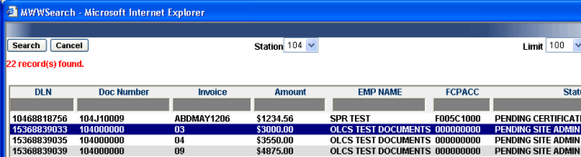
- Select the document that needs to be corrected.
- Delete the FCPACC if needed.
- Enter the correct PO#.

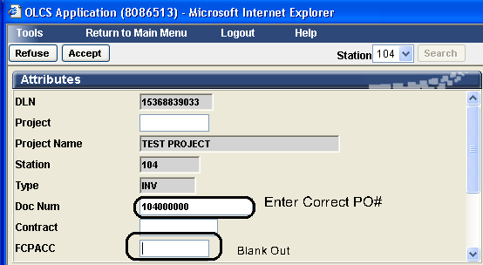
- Select the Cancel button. You will be prompted to save your changes, select Yes.

Important! Please do not select "Accept" when correcting the PO number. The “Accept” selection is used exclusively to certify an invoice for payment only
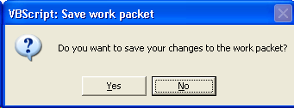
- The invoice is now ready for the Project Engineer or Project Manager to view and certify as well as the Contract Officer if Dual Certification is required.
NOTE: If Dual Certification is required the Project Engineer / Project Manager must approve FIRST before the Contracting Officer certifies or the certification stamp will have to be stripped and the document sent back through the system.

Project Engineer or Project Manager
The options seen below are available when the Project Engineer or Project Manager logs on.

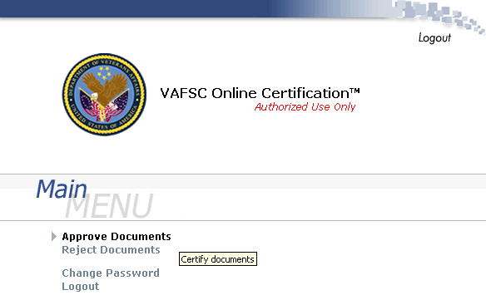

- Approve Documents - Use this option to approve an invoice and send to the Contract Officer
- Reject Documents - Use this option to reject an invoice
- Change Password - Use this option to change your login password
- Logout - Use this option to logout of the application
Certifying Invoices as a Project Engineer / Project Manager
If you have an invoice that requires certification you will receive an e-mail notification informing you how many old and new invoices require your review. The e-mail notification will be sent daily as long there are invoices awaiting your action. To review, certify, or refuse the invoice, login to the OLCS. The e-mail will contain a link (or URL) to login to the OLCS.
Once you have logged into the system, the main menu is displayed. As a Certifying Official you can review invoices for certification by clicking Certify Documents from the main menu. A list of all invoices requiring certification will appear. The list contains only documents for your station that are associated with the Fund Control Point (FCP) assigned to your Username. As a Project Engineer or Project Manager you can review invoices for certification and prepare them for the Contract Officer to certify for payment. Click Approve Documents from the main menu.
- Verify the PO# is correct.
- Enter the dollar amount to be applied against the PO# or add additional PO #’s and dollar amounts as needed.
- Click “Check Available Funding” to confirm available funds.
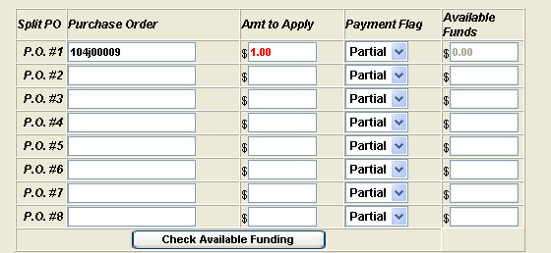
- If funds are not available, you will receive a notification. Please contact a fiscal officer.

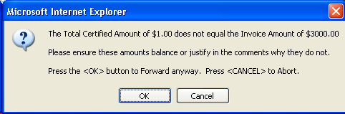
- Add log / receive date and the payment terms in the comment field if applicable. 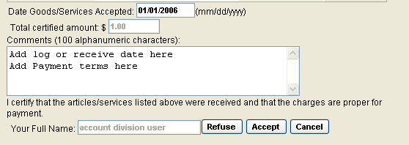

- Refuse or accept accordingly.

Dual Certification
If dual certification is needed, then both the Contract Officer and the Project Engineer or Project Manager must both certify the document for payment.
NOTE: If Dual Certification is required the Project Engineer / Project Manager must approve FIRST before the Contracting Officer certifies or the certification stamp will have to be stripped and the document sent back through the system.
Contract Officer
The options seen below are available when the Contract Officer logs on.
- Approve Documents - Use this option to approve an invoice
- Reject Documents - Use this option to reject an invoice
- Change Password - Use this option to change your login password
- Logout - Use this option to logout of the application
Dual Certification
If dual certification is needed, then both the Contract Officer and the Project Engineer or Project Manager must both certify the document for payment.
NOTE: If Dual Certification is required the Project Engineer / Project Manager must approve FIRST before the Contracting Officer certifies or the certification stamp will have to be stripped and the document sent back through the system.
Certifying Invoices as a Contract Officer
- Confirm that the Project Engineer or Project Manager’s approval stamp is already present on the document if Dual Certification is necessary.
- Verify the PO# is correct.
- Enter the dollar amount to be applied against the PO# or add additional PO #’s and dollar amounts as needed.
- Click “Check Available Funding” to confirm available funds.
- If funds are not available, you will receive a notification. Please contact a fiscal officer.
- Add log / receive date and the payment terms in the comment field if applicable.
- Refuse or accept accordingly.

