CLEARING CONVENIENCE CHECK ADVANCES

Convenience check disbursements are posted with a CB01 transaction which establishes an advance to the station that issued the check.

Below are transactions which can be used to clear Convenience Checks:

a. Liquidate SO obligation DD-03
b. Liquidate PFOP TR-24
c. Liquidate Suspense TR-24
d. Liquidate Travel Obligation TY-05
e. Establish Travel Advance IF-04
f. Payroll/Award payment SV-56

On all transactions with the exception of the DD-03 use a TR-15 referencing the advance number in addition to one of the above transactions(B-F). Be sure to use the "y" indicator on the TR transaction, otherwise the advance will remain on the books. The deposit number should be the same as the Direct Disbursement/Schedule number used on the expensing transaction. If no Direct Disbursement/Schedule number field is available, use the Document ID of the expensing transaction.

The following pages are some samples of the different ways this advance can be cleared:

a. Liquidate SO obligation (DD03)
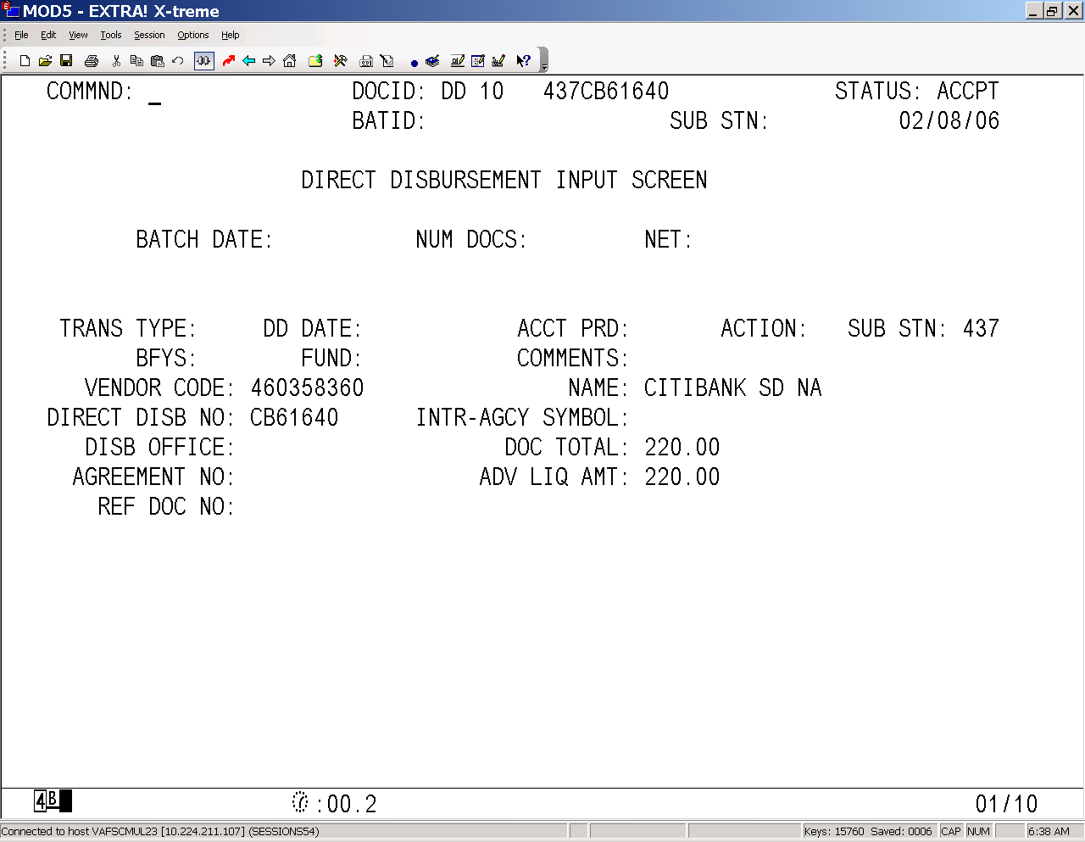
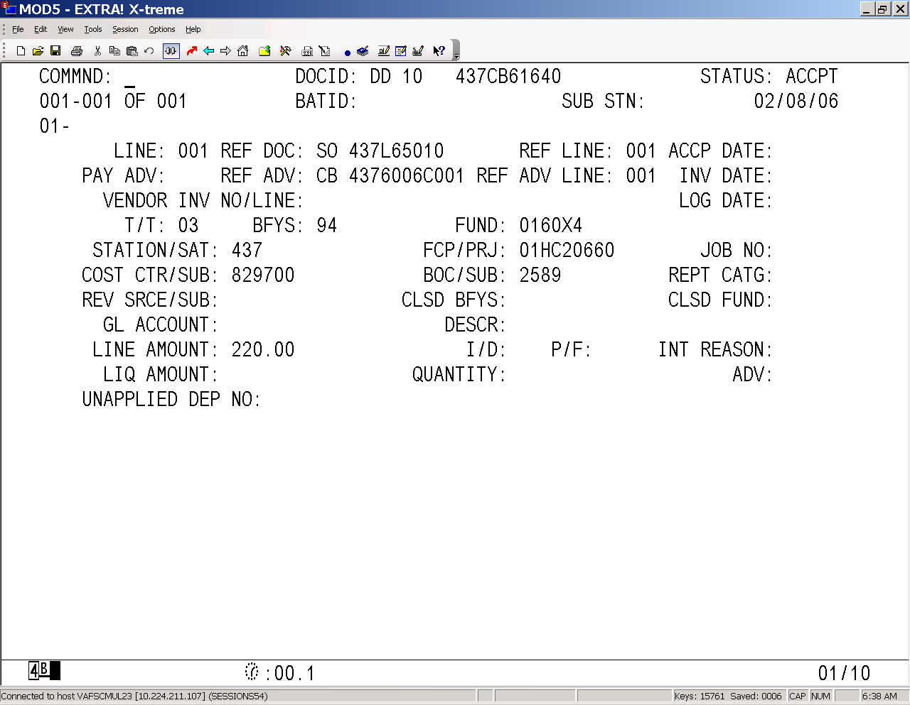

- Liquidate PFOP (TR24)
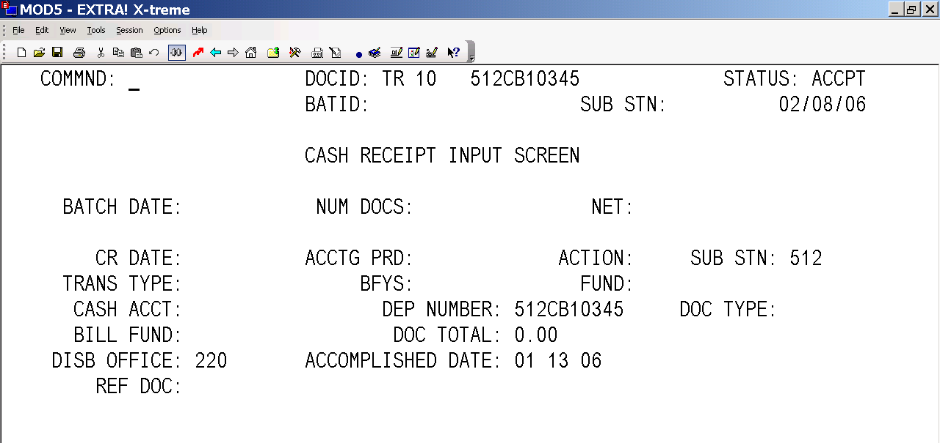
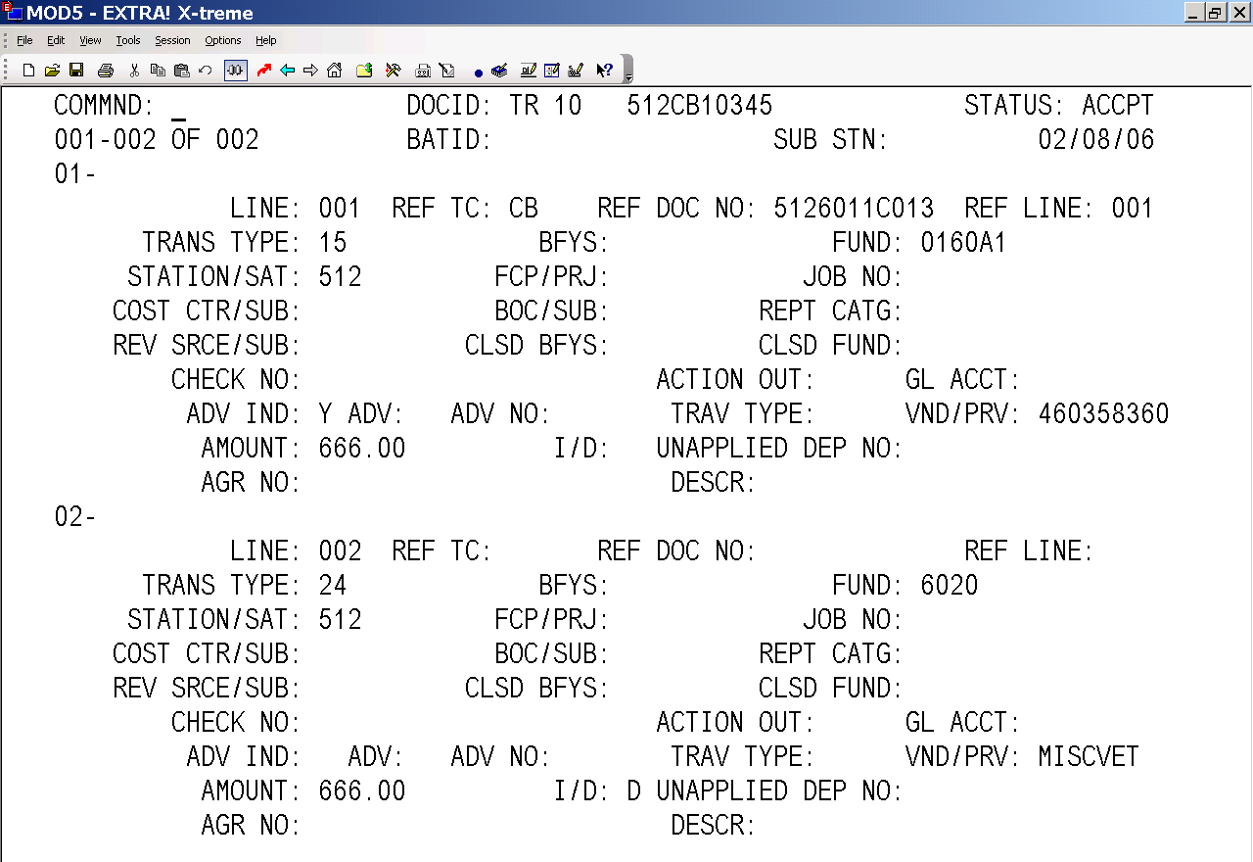

- Liquidate Suspense (TR24)
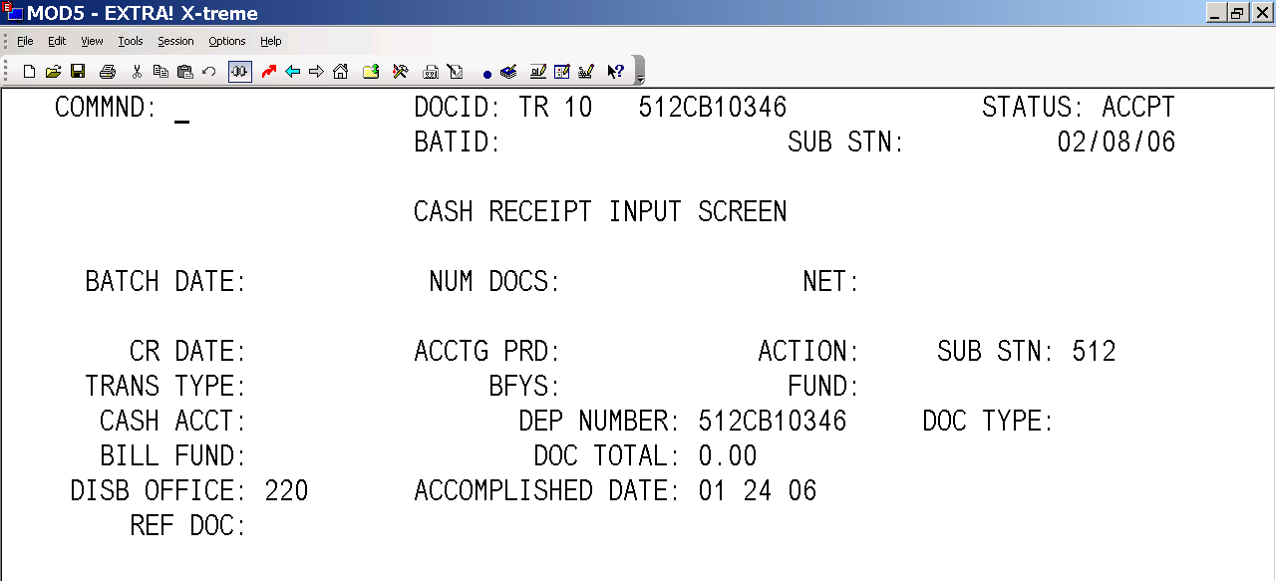
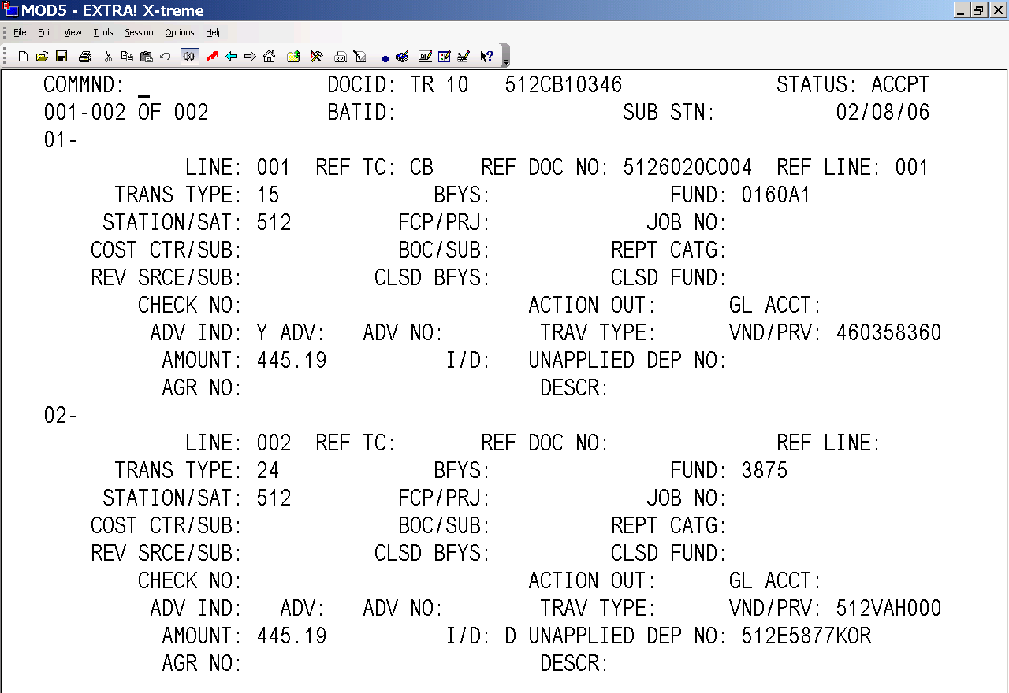

e. Establish Travel Advance 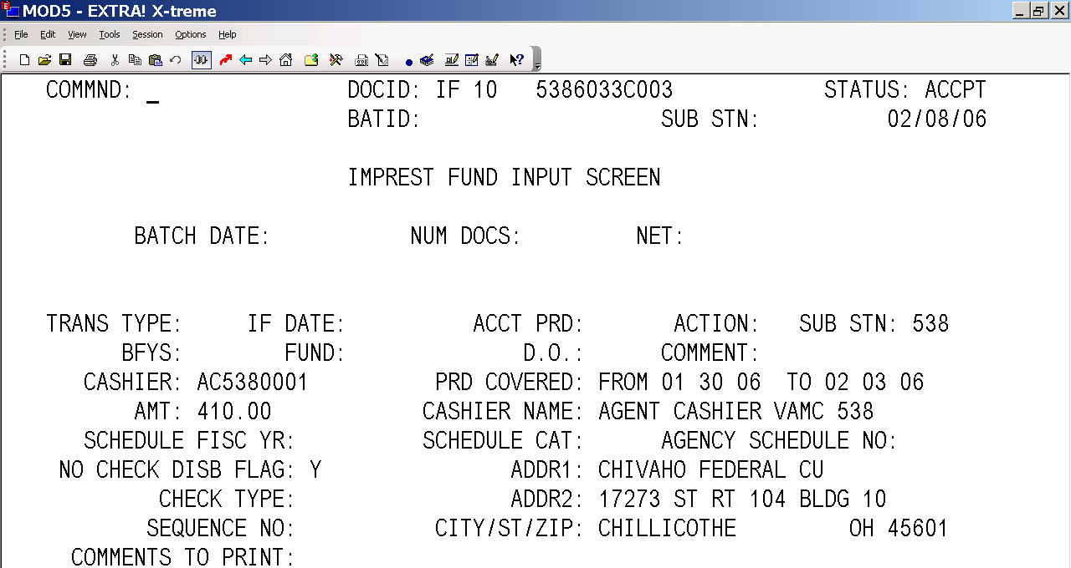
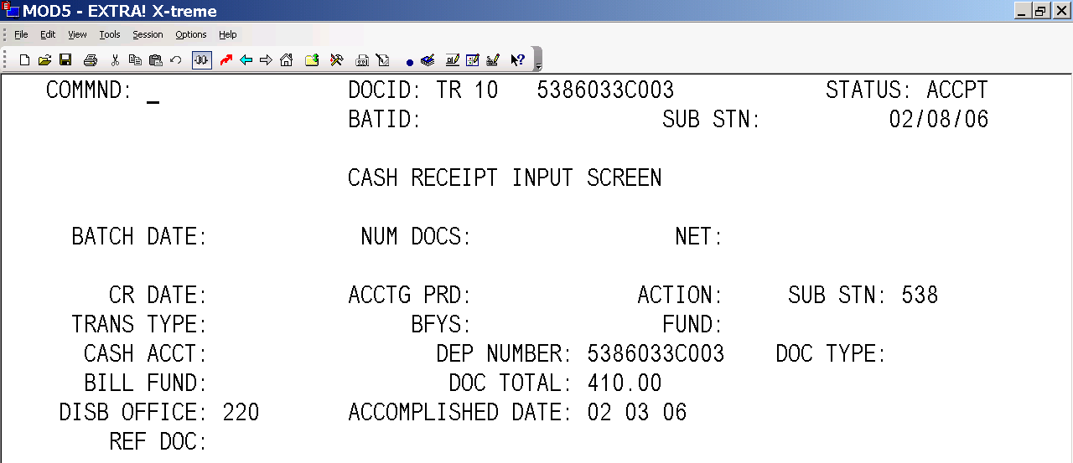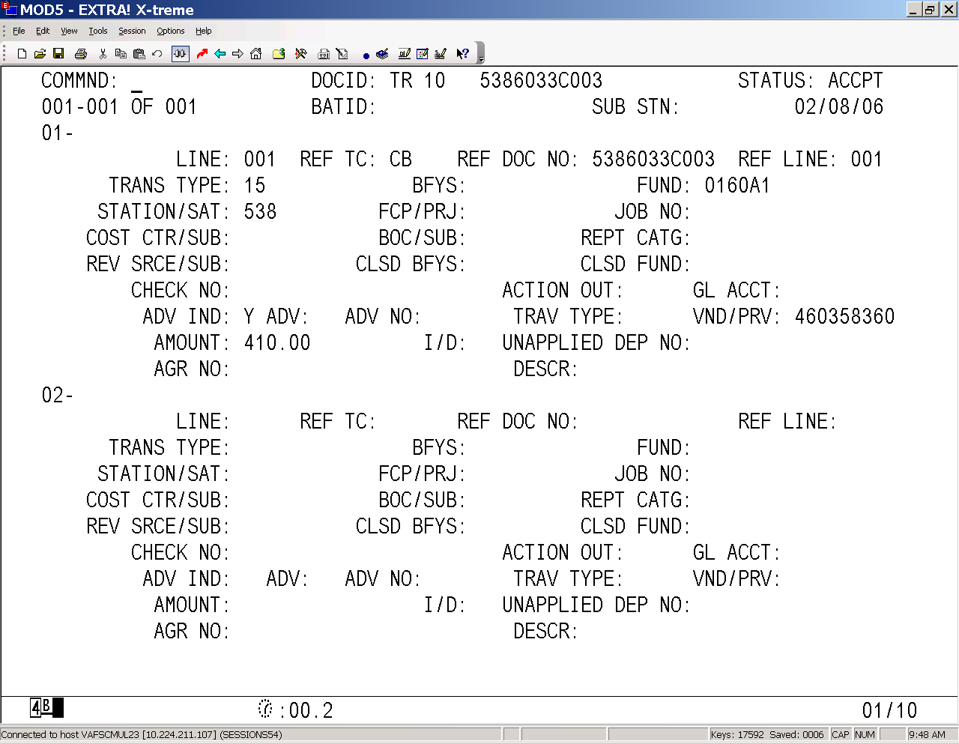

ADVANCE INSTRUCTIONS

There are several stations inquiring about adjustments advanced to them by AFC Reports staff with DV 01 or DV 04 transactions. These record a transfer from 36001200 to another Agency Location when Obligations are unknown to the 224 Processing staff. Once the 224 Processing staff records the DV 04 transaction stations may use the following procedures:

ET01 to charge appropriation/fund or SV56 to charge PAID appropriation/fund
TR15 with a ‘Y’ indicator to clear the advance

Please direct questions to Simmone Williams at 512-460-5111

